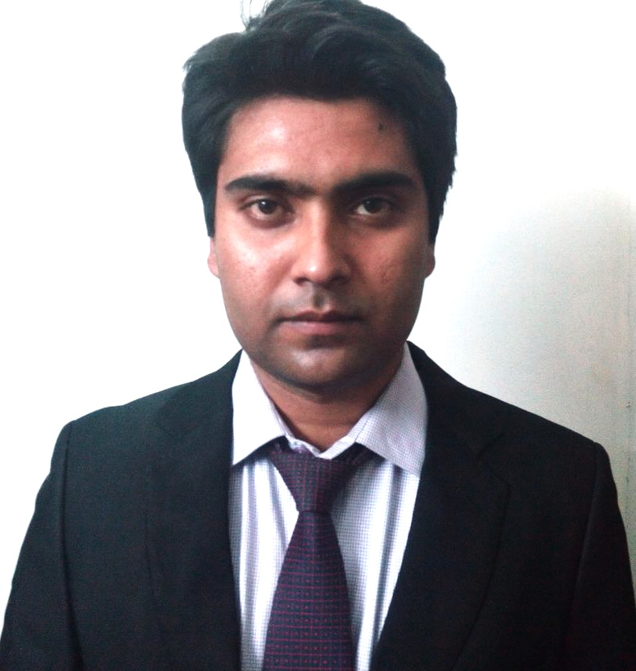

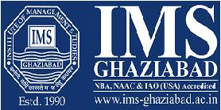

**NAME:** UTKARSH SINGH  
**EMAIL ID**:utkarshsingh0001@gmail.com   
**Contact Number**: 9871183089

**Address:**B-3,86 Noida Sec 34

**PGDM Specialization:-**Finance and Marketing

**CAREER OBJECTIVE**

Want to extract my skills in the challenging environment where my excellent finance and marketing analytical and technical skills can be utilized to improve the organization benefit and also by holding management responsibilities

**PROFESSIONAL QUALIFICATION**

|  |  |  |  |  |
| --- | --- | --- | --- | --- |
| **YEAR** | **DEGREE** | **PERCENTAGE** | **INSTITUTE** | **UNIVERSITY** |
| 2013-2015 | PGDM | 7.7 CGPA | IMS GHAZIABAD | AICTE |
| 2010-2013 | B.COM | 55% | MGKVP | MGKVP |
| 2010 | 12 | 58% | RAJ ENGLISH SCHOOL | C.B.S.E |
| 2007 | 10 | 59% | SANT ATULANAND | C.B.S.E |

**INTERNSHIP SYNOPSIS**

**Organization Name:** Nucleus School of Banking Technology a division of “NSEL”

**Duration of Internship:** 09-06-2014 to 30-07-2014

**Title:** Comparative Analysis of Banks and Loan Repayment Schedule

**Inference & Its Alignment to Business Goals:** Process by which banks provides loan and its value added services by which it makes profit

**LIVE PROJECTS & INDUSTRIAL VISITS**

**Organization:** Big Bazaar “Future Retail Group”

**Duration:** 09-08-13 to 15-08-13

**Key take-away from the live Project**

Understanding consumer buying behavior and Customer Relationship

**Organization**:IndusInd Bank

**Department:**Credit Cards and Personal Loans

**Organization:** Mother Dairy

**Department:** Milk sterilization and its distribution channel

**CERTIFICATE PROGRAMME / WORKSHOPS / CONFERENCES**

* Participated in two day program of “Sales and Negotiation Skill” conducted by **Surge**.
* Participated in Six Sigma workshop held at IMS Ghaziabad
* Participated as a volunteer in Global Net International Conference at Hotel Taj Palace New Delhi
* Participated as a volunteer 25th National Convention “Growth in times of uncertainty “by Ghaziabad Management Association
* Participated in International Conference on “Reinventing Strategy” at IMS Ghaziabad
* Attended the certification program which was conducted by GHRDC for student development.

**ACHIEVEMENTS**

* Runner-Up in “Youth Parliament” Group competition in Jamia Hamdard University, New Delhi
* Winner of “Fashion Show” Intercollege Festival “Melange” at IMS Ghaziabad
* Letter of appreciation in 7 days project at Raksha Enterprises Varanasi
* Letter of appreciation in live project at Big Bazzar
* Actively participated in various inter-department fest and inter-college fest
* Coordinator of Organizing Committee in Department fest and inter-college fest Melange

**KEY ATTRIBUTES**

**Punctuality and Adaptability**

**Multi-tasking skills**

**Interpersonal skills**

**Reliable and consistent**

**INTERESTS & PASSION**

Driving Car and Bikes

Helping poor’s

Surfing on Internet

Photography

**PERSONAL DETAILS**

**Date of Birth :** 01-11-1990

**Gender :** Male

**Fathers Name :** Late Om Prakash Singh **Passport No. :** Z2832277 **Languages Known :** English, Hindi

**Computer Efficacies**: MS Office, Tally 7.0

**Permanent Address** : H-58 V.D.A Colony Chandmari, Badalapur Varanasi

**DECLARATION**

I hereby declare that the information provided above is true and the best of my knowledge.

Date:

Place: Ghaziabad Signature